TURN THE CURVE REPORT
Maternal Health
June 2022 (2020 Data)
Population Result: Women will have healthy pregnancies with positive birth outcomes.
Indicators
- Decreased rates of c-sections, including Nulliparous, Term, Singleton, Vertex Births
- Increased rates of early entry to prenatal care
- Decreased rates of maternal health-related preconception, prenatal, and inter-conception conditions
  - pre-pregnancy bmi
  - smoking
  - pre-pregnancy diabetes
  - gestational diabetes
  - pre-pregnancy hypertension
  - gestational hypertension
  - obesity, inter-pregnancy intervals, hypertension, diabetes)
- Decreased rates of maternal mortality
Data Source: Florida Health Charts and CDC WONDER

Cesarean Births to Low-Risk Mothers with No Previous Births
Cesarean deliveries, or C-sections, can prevent injury and death in women who are at higher risk of complicated deliveries or have unexpected complications. C-sections can also prevent injury and death in their newborns. But C-sections are linked to increased risk of infections and blood clots, and many women who aren’t at higher risk for delivery complications get unnecessary C-sections. Various evidence-based strategies aimed at hospitals and health care providers can help reduce C-sections in low-risk women.
Over 40% of all births in Broward County between 2010 and 2020 were delivered by Cesarean-section (primary C-sections, repeat C-sections, and C-section births with unknown delivery history). The rate of Cesarean section births in Broward has been statistically significantly higher than the state since 2010. In 2020, Broward had the 3rd highest percentage of C-sections in the state, and 2nd highest percentage of the six counties with the greatest number of births in the state.
Cesarean Section Deliveries, Percentage of all Deliveries

Source: Florida Health Charts, Florida Department of Health, Bureau of Vital Statistics
Counties with the Highest Percentage of Cesarean Section Deliveries, 2020
Cesarean Section Deliveries, 2020
County | Count | Denominator | Percent
Miami-Dade | 12,632 | 27,663 | 45.7
Madison | 90 | 214 | 42.1
Broward | 8,264 | 19,943 | 41.4
Charlotte | 418 | 1,043 | 40.1
Wakulla | 120 | 308 | 39.0
Jackson | 187 | 483 | 38.7
Glades | 27 | 71 | 38.0
Monroe | 254 | 677 | 37.5
Taylor | 72 | 192 | 37.5
Calhoun | 47 | 126 | 37.3

Cesarean Sections by Race and Ethnicity
- Rates for all Broward Mothers have been statistically significantly higher than the state since 2010
Cesarean Section Percentage of all Deliveries by Race

Cesarean Section Percentage of all Deliveries by Ethnicity

Nulliparous, Term, Singleton, Vertex Cesarean Sections

Of the 19,943 births in Broward County in 2020, 76.2%, or 15,207 were to women who have not previously given birth (including stillbirths and fetal deaths or miscarriages). Of all births, 9,271 were nulliparous and term, with a gestational age between 37 and 39 weeks. There were 9,118 nulliparous, term, singleton births in 2020 and 8,776 nulliparous, term, singleton births who presented in the head down position. The expectation is that barring complications, these babies would be delivered vaginally. However, 2,020 (23.0%) of the 8,776 babies who were NTSV were delivered by Cesarean section.

The women who delivered these babies by Cesarean section were:

Women who delivered NTSV infants by Cesarean section were more likely to be:
- Educated (68.7% of women had some college or higher levels of educational attainment)
- Older (60.4% were over the age of 30, with an additional 24.5% between 25 and 29 years of age)
- Married (57.4% were married)

They were also more likely to:
- Enter prenatal care in their first trimester (72.67%)
- Have a pre-pregnancy BMI that was overweight or obese

They were less likely to:
- Have pre-pregnancy diabetes (1%)
- Have gestational diabetes (7%)
- Have pre-pregnancy hypertension (2%)
- Have gestational hypertension (9%)
- Have any STD noted (2%)

In terms of source of payment for the Cesarean delivery:
- 37% were paid by Medicaid
- 54% were paid by private insurance
- 8% were self-pay
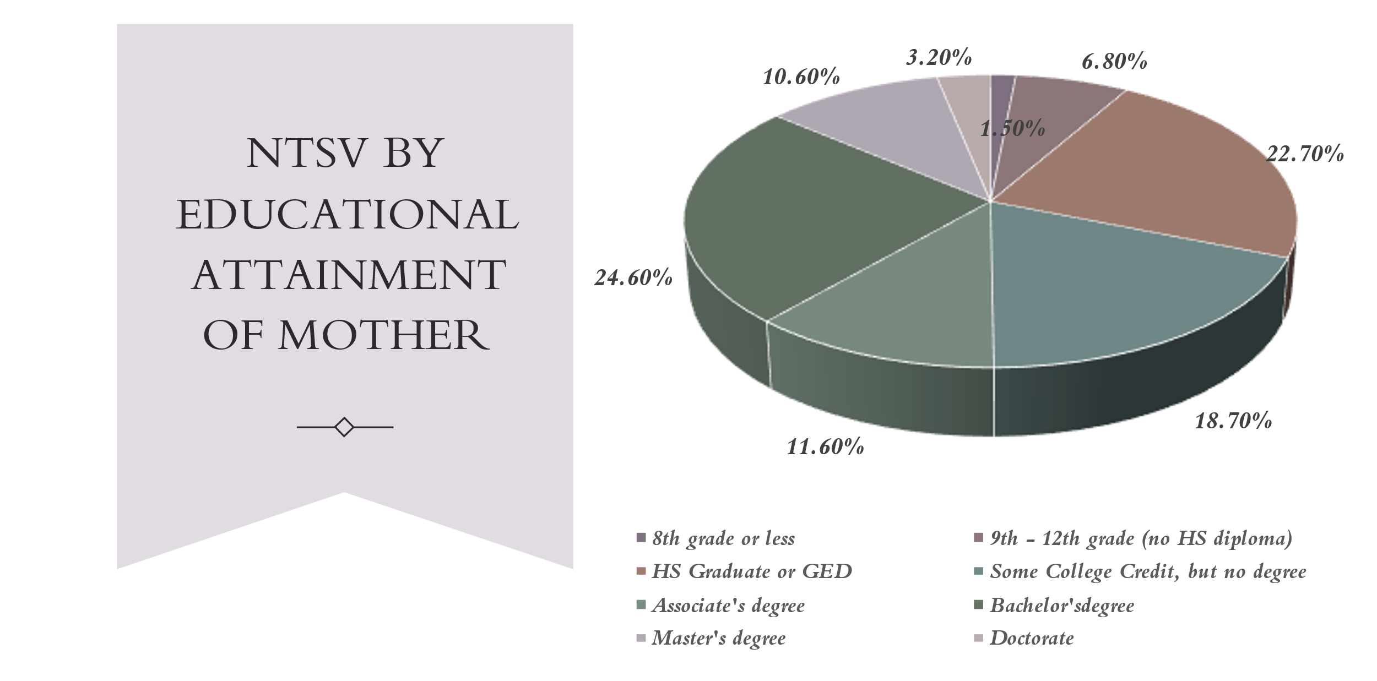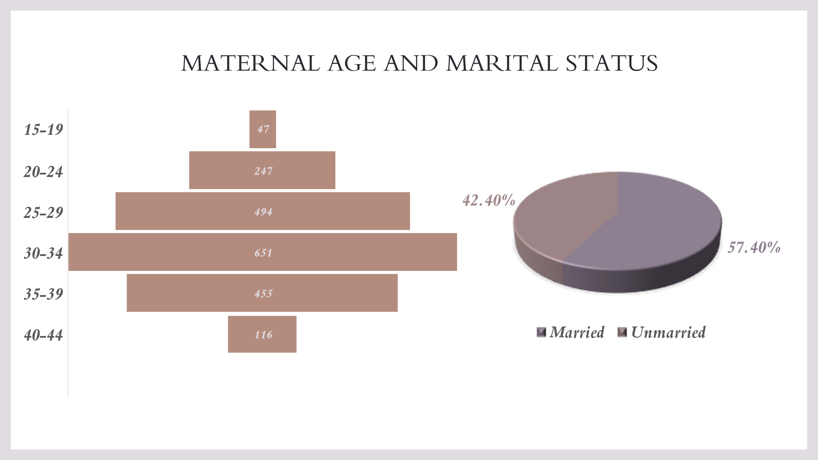

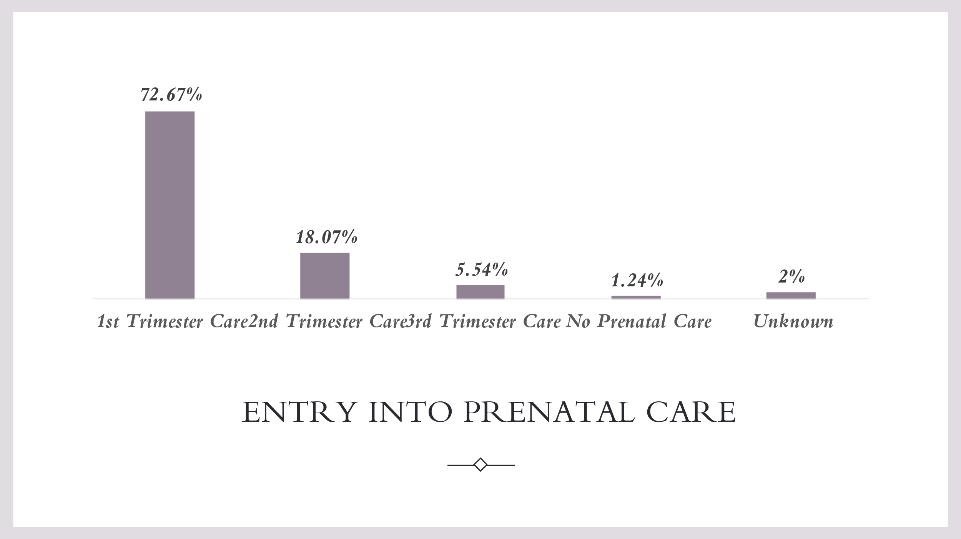
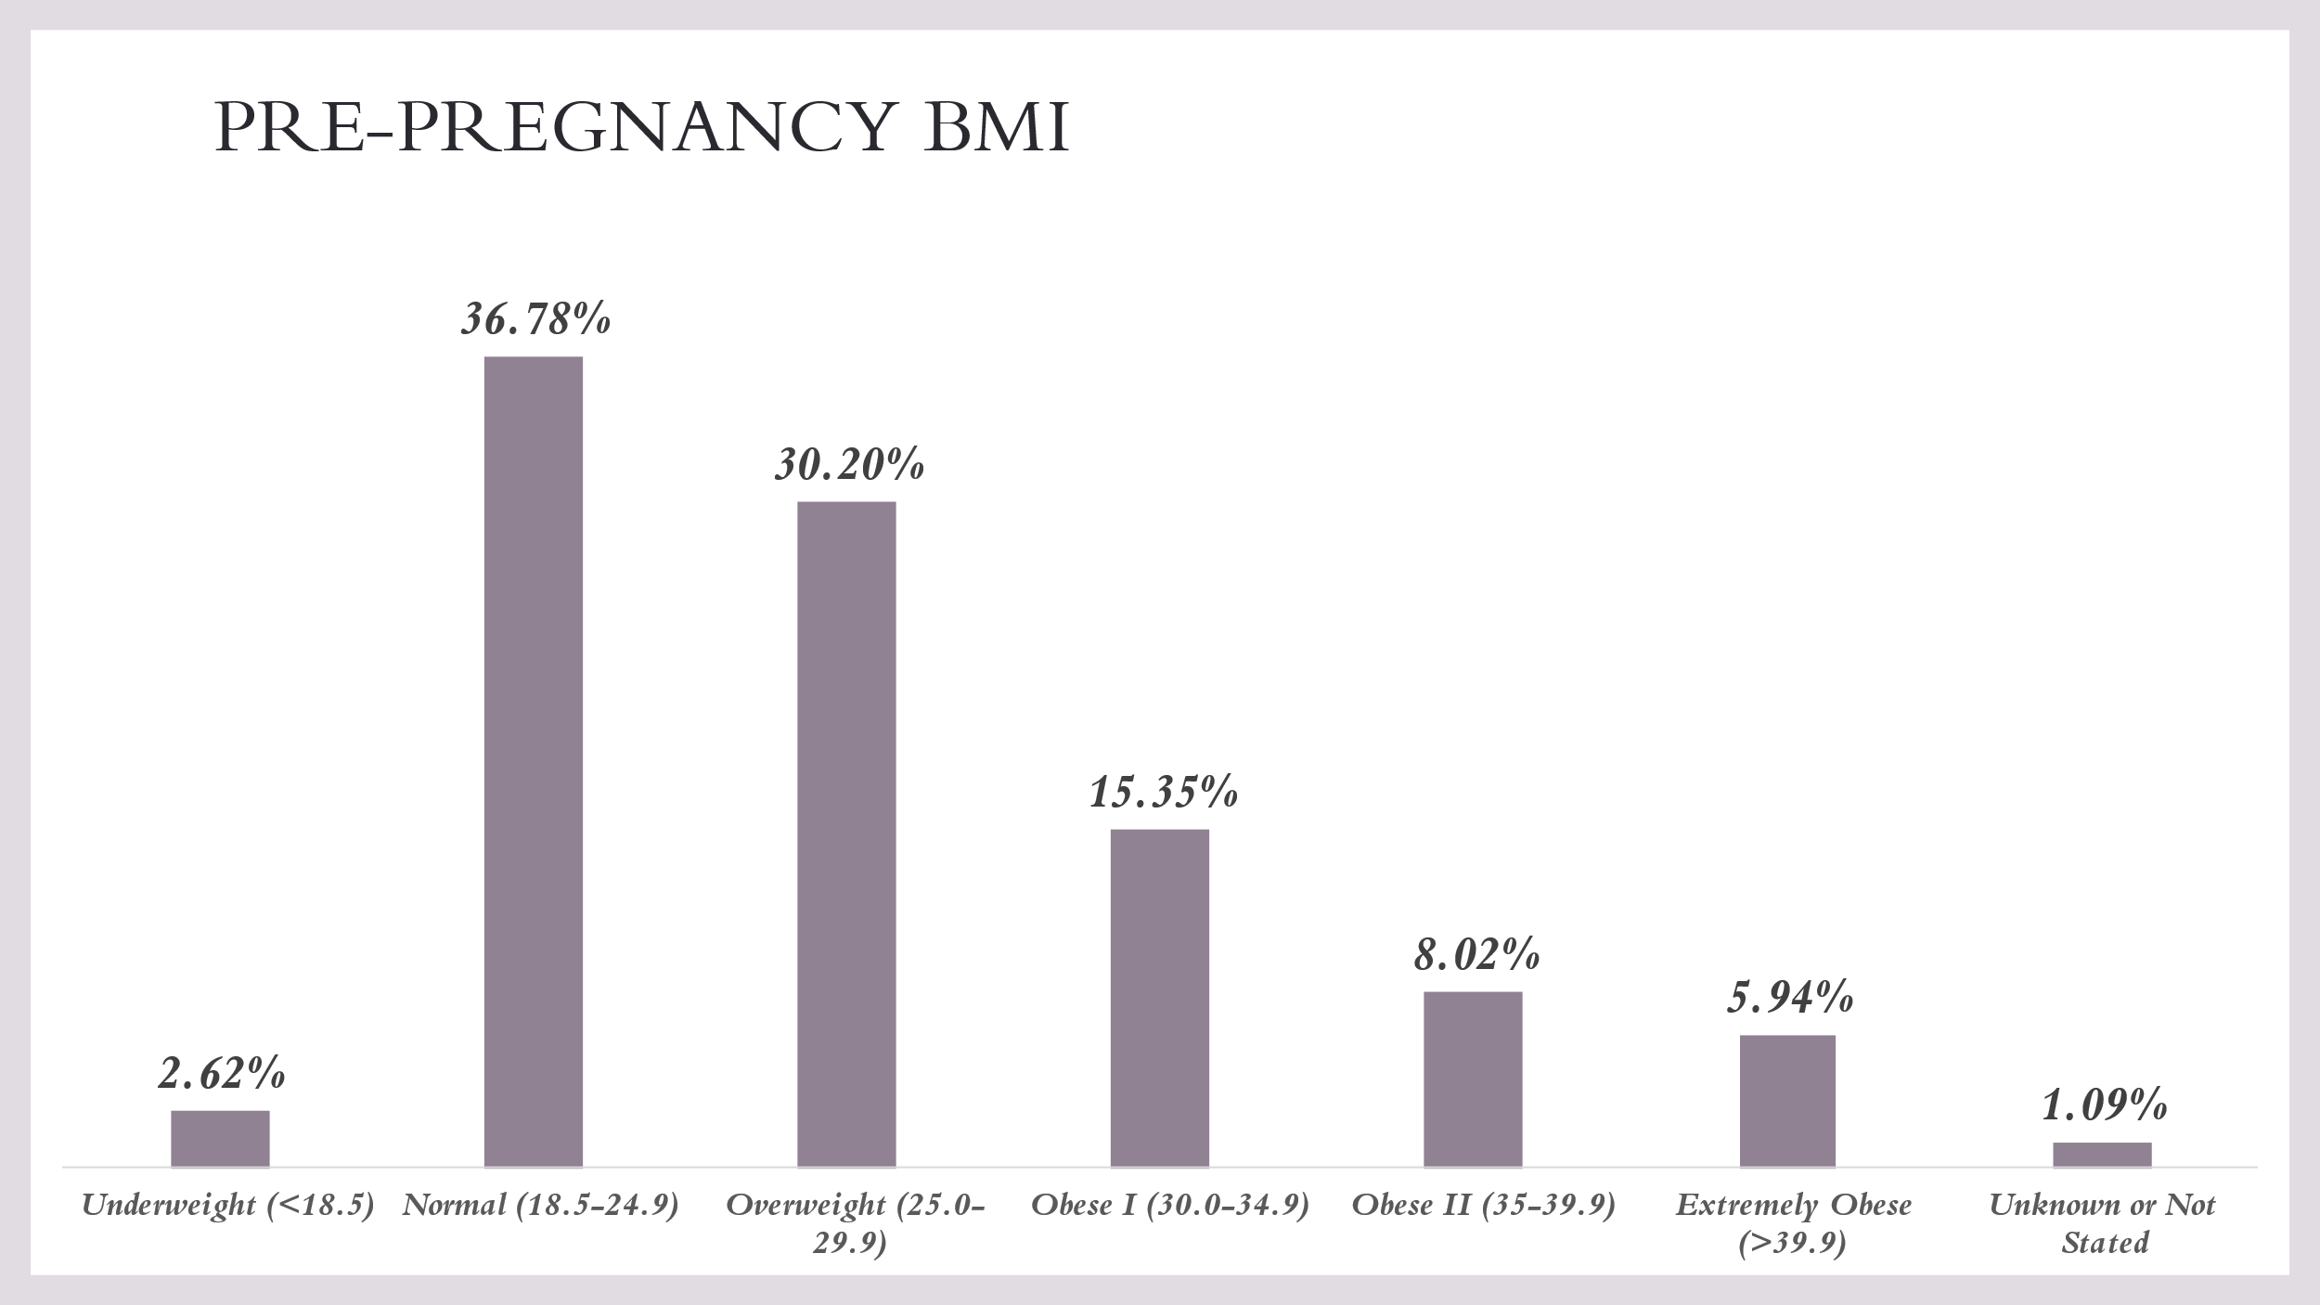

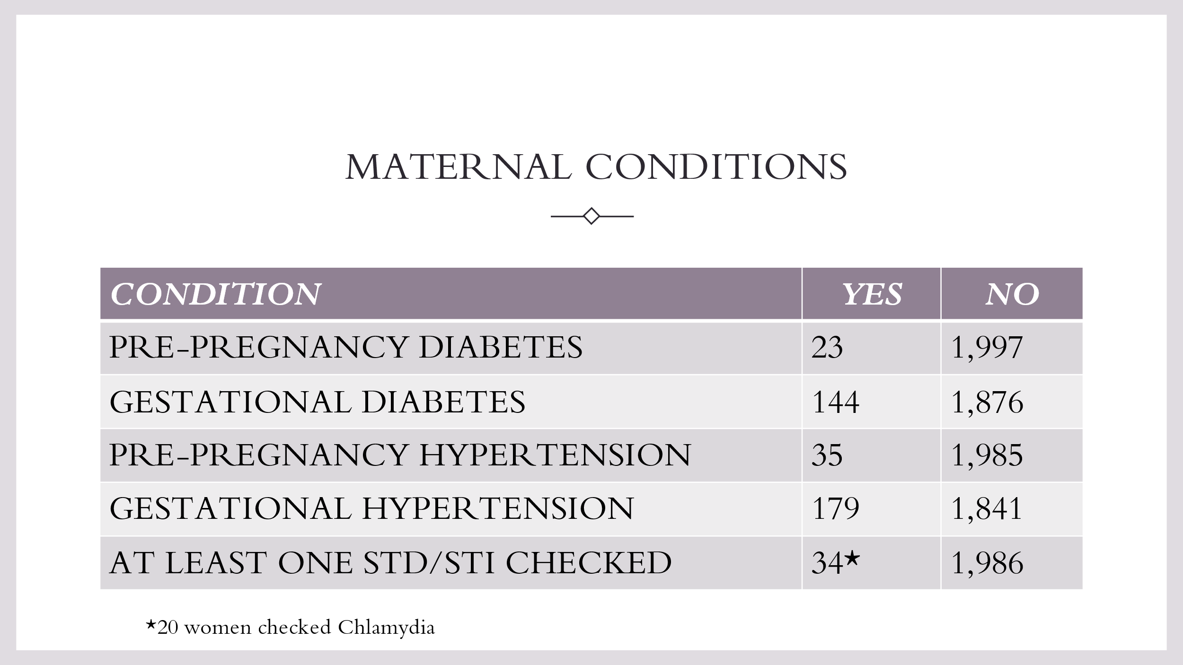
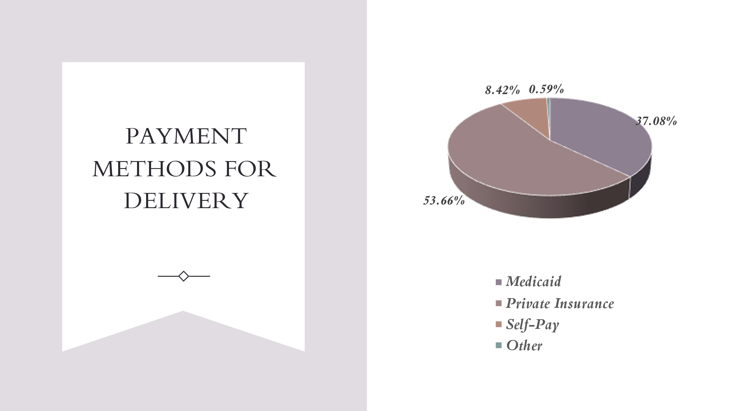
Zip Code Data
While data for the NTSV births by zip code or census tract was not available, the following shows the percent of nulliparous births and the percent of C-section births for all births in the zip codes with the greatest number of births.
Zip Code | Total Births | Nulliparous Births | % of All Births | Cesarean Sections ALL | % of All Births
33009 | 680 | 282 | 41% | 435 | 64%
33021 | 574 | 229 | 40% | 200 | 35%
33023 | 751 | 290 | 39% | 332 | 44%
33024 | 742 | 314 | 42% | 292 | 39%
33025 | 911 | 414 | 45% | 402 | 44%
33064 | 710 | 266 | 37% | 282 | 40%
33065 | 636 | 244 | 38% | 266 | 42%
33068 | 744 | 281 | 38% | 321 | 43%
33311 | 1,020 | 322 | 32% | 413 | 40%
33312 | 725 | 280 | 39% | 280 | 39%
33313 | 893 | 298 | 33% | 364 | 41%
33319 | 574 | 220 | 38% | 237 | 41%

Early and Adequate Prenatal Care
Prenatal care is most effective when it starts early and continues throughout pregnancy. It can help prevent and address health problems in both mothers and babies. Interventions to increase access to health care can help more women get the prenatal care they need.
In 2020:
- Over 1,000 Broward women did not have a known prenatal care status
- Over 1,500 had late (3rd trimester) or no prenatal care
- Broward Black women (64.4%) and Broward Haitian women (58.1%) were less likely to have 1st trimester prenatal care than Broward White women (72.6%) and Broward Hispanic women (69.5%)
- Broward Black women (3.1%) and Broward Haitian women (3.3%) were more likely to have no prenatal care than Broward White women (1.5%) and Broward Hispanic women (1.4%)
- Broward Hispanic women (5.7%), Broward Black women (5.6%), Broward White women (4.8%) and Broward Haitian women (4.0%) had unknown prenatal care status
Women with unknown or late/no prenatal care represented 12.5% of all Broward births in 2020.

Adequate Prenatal Care
The Kotelchuck Index, also called the Adequacy of Prenatal Care Utilization (APNCU) Index, classifies the adequacy of initiation as follows: pregnancy months 1 and 2, months 3 and 4, months 5 and 6, and months 7 to 9. A ratio of observed to expected visits is calculated and grouped into four categories: Inadequate (received less than 50% of expected visits), Intermediate (received 50%-79% of expected visits), Adequate (received 80%-109% of expected visits), Adequate Plus (received 110% or more of expected visits). Mothers with unknown prenatal care are excluded from the denominator in calculating the percentage.
This indicator is a measure of the adequacy of prenatal care provided to a woman by health care providers during the prenatal period. The adequacy of prenatal care utilization index provides a more comprehensive measure of prenatal care utilization than the timing of prenatal care. High-risk pregnant women are likely to have high rates for adequate+plus care due to the many visits they receive.
The rate of adequate prenatal care in Broward County increased between 2011 and 2013, then began to decline until 2017, when it began increasing again and then decreased between 2019 and 2020. The rate has been statistically significantly lower than the state between 2016 and 2019, with no significant difference in 2020.
Adequate Prenatal Care

Source: Florida Health Charts, Florida Department of Health, Bureau of Vital Statistics

Rate of Adequate Prenatal Care by Race and Ethnicity
- The rate of adequate prenatal care for Broward White women was statistically significantly higher than the state in 2012-2015 and statistically significantly lower in 2017-2018.
- The rate of adequate prenatal care for Broward Black women was statistically significantly higher than the state in 2011-2014 and 2019 and statistically significantly lower in 2017.
- The rate of adequate prenatal care for Broward Other women was statistically significantly higher than the state in 2012-2014 and 2016, 2018, and 2019.

Adequate Prenatal Care by Race

Source: Florida Health Charts, Florida Department of Health, Bureau of Vital Statistics

Rate of Adequate Prenatal Care by Ethnicity
- The rate of adequate prenatal care for Broward Hispanic women was statistically significantly higher than the state in 2013, 2015, and 2020 and statistically significantly lower than the state in 2010, 2017, and 2018.
- The rate of adequate prenatal care for Broward non-Hispanic women was statistically significantly higher in 2013 and 2014 and statistically significantly lower in 2015-2020.
Adequate Prenatal Care by Ethnicity

Source: Florida Health Charts, Florida Department of Health, Bureau of Vital Statistics

No Prenatal Care
In 2020, 433 Broward women had no prenatal care. The rate of no prenatal care was statistically significantly higher than the state from 2011-2017.
Rate of No Prenatal Care

Source: Florida Health Charts, Florida Department of Health, Bureau of Vital Statistics

No Prenatal Care by Race
- The rates for Black and White mothers with NO prenatal care increased between 2018 and 2019 and decreased between 2019 and 2020.
Rate of No Prenatal Care by Race

Source: Florida Health Charts, Florida Department of Health, Bureau of Vital Statistics

The following chart represents the numbers of White and Black women with no prenatal care by race between 2011 and 2020.
Numbers of Women with No Prenatal Care by Race
 | Broward  White | Broward  Black
2020 | 166 | 232
2019 | 197 | 260
2018 | 182 | 246
2017 | 196 | 330
2016 | 200 | 291
2015 | 191 | 298
2014 | 145 | 243
2013 | 165 | 231
2012 | 140 | 210
2011 | 106 | 191
2010 | 120 | 165
Source: Florida Health Charts, Florida Department of Health, Bureau of Vital Statistics

No Prenatal Care by Ethnicity, 2020
The rates for Hispanic and non-Hispanic Mothers with NO prenatal care increased between 2018 and 2019 and decreased between 2019 and 2020
The following chart represents the number of women with no prenatal care by ethnicity between 2011 and 2020.
Rate of No Prenatal Care by Ethnicity

Source: Florida Health Charts, Florida Department of Health, Bureau of Vital Statistics
Numbers of Women with No Prenatal Care by Ethnicity
 | Broward  Hispanic | Broward  Non-Hispanic
2020 | 92 | 333
2019 | 131 | 357
2018 | 106 | 346
2017 | 111 | 446
2016 | 132 | 405
2015 | 115 | 416
2014 | 83 | 335
2013 | 90 | 334
2012 | 76 | 289
2011 | 58 | 251
2010 | 64 | 238
Source: Florida Health Charts, Florida Department of Health, Bureau of Vital Statistics

1st Trimester Care
The rate of Broward Mothers entering Prenatal Care in their 1st Trimester has been statistically significantly lower than the rate of all Florida Mothers since 2011.
Rates of 1st Trimester Prenatal Care

Source: Florida Health Charts, Florida Department of Health, Bureau of Vital Statistics

1st Trimester Prenatal Care Status by Race and Ethnicity
- Rates for White Mothers were statistically significantly higher than the state from 2010-2013 and lower from 2014-2020
- Rates for Black Mothers have been statistically significantly lower than the state since 2012
- Rates for Hispanic and non-Hispanic Mothers have been statistically significantly lower than the state since 2014
Rates of 1st Trimester Prenatal Care by Race

Source: Florida Health Charts, Florida Department of Health, Bureau of Vital Statistics

Rates of 1st Trimester Prenatal Care by Ethnicity

Source: Florida Health Charts, Florida Department of Health, Bureau of Vital Statistics

3rd Trimester Care
The rate of Broward Mothers entering prenatal care in their 3rd trimester has been statistically significantly higher than the rate of all Florida Mothers in 2011 and since 2013.
Rates of 3rd Trimester Care

Source: Florida Health Charts, Florida Department of Health, Bureau of Vital Statistics

3rd Trimester Prenatal Care Status, by Race and Ethnicity
- Rates for White Mothers have been statistically significantly higher than the state since 2014
- Rates for Black Mothers have been statistically significantly higher than the state between 2016 and 2019
- Rates for Hispanic Mothers were statistically significantly higher than the state between 2016 and 2018 and for non-Hispanic Mothers all years between 2013 and 2020
Rates of 3rd Trimester Prenatal Care by Race

Source: Florida Health Charts, Florida Department of Health, Bureau of Vital Statistics
Rates of 3rd Trimester Prenatal Care by Ethnicity

Source: Florida Health Charts, Florida Department of Health, Bureau of Vital Statistics

Maternal Deaths
Women in the United States are more likely to die from childbirth or problems related to pregnancy than women in other high-income countries. In addition, there are persistent disparities by race/ethnicity. Improving the quality of medical care for women before, during, and after pregnancy can help reduce maternal deaths.

Severe Maternal Complications during Delivery Hospitalizations
Severe complications during labor and delivery can lead to serious and lasting health problems for women, like stroke or kidney problems. Rates of severe maternal complications have increased in recent years, and there are disparities by race/ethnicity. Making sure women get high-quality health care both before and during pregnancy can help reduce severe maternal complications. While data exists for this at the state level, the measurement is not the same as the Healthy People 2030 objectives and is therefore not included here. Healthy People 2030 measures the rate per 10,000 deliveries while Florida Health Charts measures per 1,000 deliveries.
Florida Health Charts defines maternal complications as Severe Maternal Morbidity (SMM), or the presence of a complication during a delivery hospitalization. Severe Maternal Morbidity includes acute myocardial infarction, aneurysm, acute renal failure, adult respiratory distress syndrome, amniotic fluid embolism, cardiac arrest/ventricular fibulation, conversion of cardiac rhythm, disseminated intravascular fibrillation, eclampsia, heart failure/arrest during surgery or procedure, puerperal cerebrovascular disorders, pulmonary edema/acute heart failure, severe anesthesia complications, sepsis, shock, sickle cell disease with crisis, air and thrombotic embolism, blood products transfusion, hysterectomy, temporary tracheostomy or ventilation.
In 2020, Florida had 28 maternal deaths. Miami-Dade had 6 maternal deaths, followed by Broward (4), and Polk (3).
Maternal Deaths by Race

Source: Florida Health Charts, Florida Department of Health, Bureau of Vital Statistics
Maternal Deaths by Ethnicity

Source: Florida Health Charts, Florida Department of Health, Bureau of Vital Statistics

Maternity Deserts
According to the March of Dimes, maternity care deserts are counties in which access to maternity health care services is limited or absent, either through lack of services or barriers to a woman’s ability to access that care. While Broward County is not lacking in birthing centers, access to care may be limited due to the availability of OB/GYNs in one’s neighborhood, not the entire county. The map below shows the number of OB/GYN offices (not practitioners) in particular zip codes. Attention should be paid to those zip codes in which the rates of preterm birth and infant mortality are high.
OB/GYN offices in Broward County
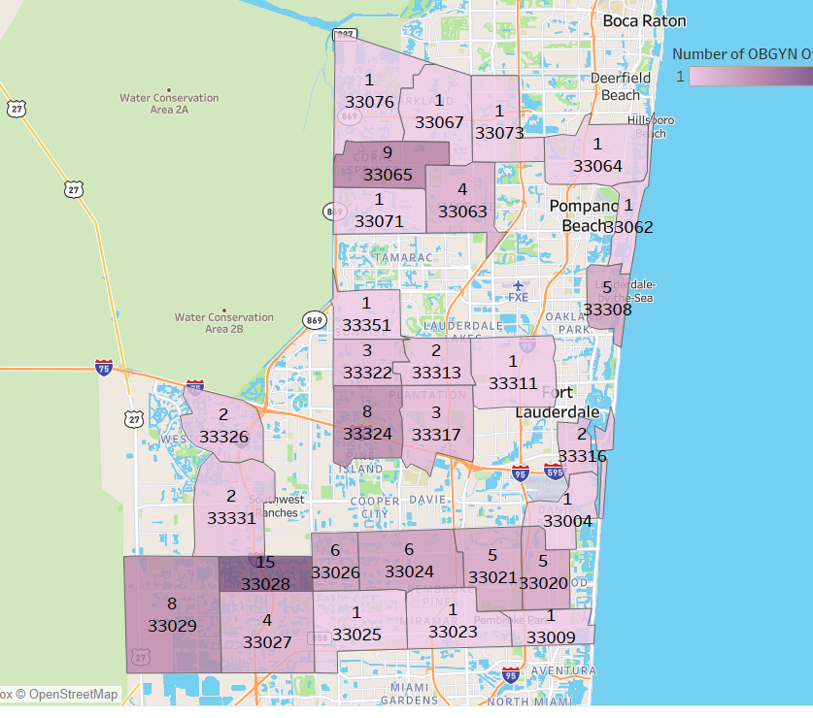
Source: Broward Healthy Start Coalition List of OB/GYN offices, 2020

Healthy Weight Prior to Pregnancy
More than half of women are overweight or underweight when they get pregnant. This is linked to complications and poor pregnancy outcomes. For example, obesity during pregnancy is linked to high blood pressure and gestational diabetes in mothers — as well as stillbirth and preterm birth in infants. Interventions related to healthy eating and physical activity can help more women have a healthy weight before getting pregnant.
Broward County has had a statistically significantly higher rate of births to mothers who were at a healthy weight at the time pregnancy occurred than the state since 2011.
In 2020, Broward County had the 9th highest rate in the state.
Rates of Mothers at Healthy Weight Prior to Pregnancy

Source: Florida Health Charts, Florida Department of Health, Bureau of Vital Statistics
Counties with Highest Percentages of Births to Mothers with Healthy Weight
Births to Mothers with Healthy Weight, 2020
County | Count | Denominator | Percent
Saint Johns | 1,010 | 2,103 | 48.0
Monroe | 306 | 668 | 45.8
Miami-Dade | 12,494 | 27,316 | 45.7
Pinellas | 3,277 | 7,201 | 45.5
Sarasota | 1,184 | 2,610 | 45.4
Seminole | 1,834 | 4,112 | 44.6
Walton | 345 | 783 | 44.1
Flagler | 329 | 747 | 44.0
Palm Beach | 5,920 | 13,687 | 43.3
Broward | 8,456 | 19,656 | 43.0
Source: Florida Health Charts, Florida Department of Health, Bureau of Vital Statistics

Births to mothers who were at a healthy weight at the time pregnancy occurred by Race and Ethnicity
- Rates for White Broward Mothers have been statistically significantly higher than the state since 2011
- Rates for Black Broward Mothers were statistically significantly higher than the state in 2011, 2012, 2015, 2017, 2018, 2019, and 2020
- Rates for Hispanic Broward Mothers have been statistically significantly higher than the state since 2011
- Rates for non-Hispanic Broward Mothers were statistically significantly lower than the state in 2014 and statistically significantly higher in 2019 and 2020
Rates of Mothers at Healthy Weight Prior to Pregnancy by Race

Source: Florida Health Charts, Florida Department of Health, Bureau of Vital Statistics
Rates of Mothers at Healthy Weight Prior to Pregnancy by Ethnicity

Source: Florida Health Charts, Florida Department of Health, Bureau of Vital Statistics

Births to mothers who were obese at the time pregnancy occurred
Broward County has had a statistically significantly lower rate of births to mothers who were obese at the time pregnancy occurred than the state since 2010.
In 2019, Broward had the 9th lowest rate in the state.
Births to Mothers who were Obese at the Time Pregnancy Occurred

Source: Florida Health Charts, Florida Department of Health, Bureau of Vital Statistics
Counties with Lowest Percentages of Births to Obese Mothers at the Time Pregnancy Occurred
Births to Obese Mothers at time Pregnancy Occurred, 2020
County | Count | Denominator | Percent
Saint Johns | 440 | 2,103 | 20.9
Miami-Dade | 5,902 | 27,316 | 21.6
Sarasota | 618 | 2,610 | 23.7
Monroe | 160 | 668 | 24.0
Walton | 188 | 783 | 24.0
Martin | 299 | 1,232 | 24.3
Pinellas | 1,805 | 7,201 | 25.1
Palm Beach | 3,440 | 13,687 | 25.1
Broward | 4,982 | 19,656 | 25.3

Births to mothers who were obese at the time pregnancy occurred by Race and Ethnicity
- Rates for all White, Black, Hispanic, and non-Hispanic Broward Mothers have been statistically significantly lower than the state since 2011

Rates of Births to Mothers who were Obese at the Time Pregnancy Occurred by Race

Source: Florida Health Charts, Florida Department of Health, Bureau of Vital Statistics
Rates of Births to Mothers who were Obese at the Time Pregnancy Occurred by Ethnicity

Source: Florida Health Charts, Florida Department of Health, Bureau of Vital Statistics

Births to mothers who were overweight at the time pregnancy occurred
Broward County has had a statistically significantly higher rate of births to mothers who were overweight at the time pregnancy occurred than the state since 2011.
Rates of Births to Mothers who were Overweight at the Time Pregnancy Occurred

Source: Florida Health Charts, Florida Department of Health, Bureau of Vital Statistics

Births to mothers who were overweight at the time pregnancy occurred by Race and Ethnicity
- Rates for White Broward Mothers were statistically significantly higher than the state in 2014
- Rates for Black Broward Mothers were statistically significantly higher than the state in 2011, and 2013-2020
- Rates for Hispanic Broward Mothers were statistically significantly higher than the state in 2017 and 2018
- Rates for non-Hispanic Broward Mothers have been statistically significantly higher than the state since 2011
Rates of Women who were Overweight at the Time Pregnancy Occurred by Race

Source: Florida Health Charts, Florida Department of Health, Bureau of Vital Statistics
Rates of Births to Mothers who were Overweight at the Time Pregnancy Occurred by Ethnicity

Source: Florida Health Charts, Florida Department of Health, Bureau of Vital Statistics
Story Behind the Curve
- The rate of births to mothers with 3rd or no prenatal care has been increasing in Broward. The Hispanic population is leveling off; however, the Black and White populations have been increasing.
- The rate of births paid through Self Pay is on the rise for White, Black/Other and Hispanic women and is greater than the rate of the State, which is decreasing.
- Broward County’s rates for births covered by Medicaid is remaining steady for Black and White births and increasing for Hispanic births. All rates are less than the state.
- The rate of babies who were born to mothers who were born in other countries is 50% overall in Broward County, with Hispanic births over 60%. The rate of Black babies born to mothers born to mothers from other countries is decreasing while the rate of White babies born to mothers from other countries is increasing.
- Broward County continues to experience a higher rate of C-section deliveries, though it has decreased slightly. White, Black, and, in particular, Hispanic women are delivering by C-section at a greater rate than the state. The rate for C-section deliveries to White women and Black/Other women is nearly the same.
- The rate of smoking during pregnancy has significantly declined in Broward County and is far lower than the state rates. White Broward women are more likely to smoke during pregnancy than Black/Other or Hispanic women.
- The rates of births to mothers with less than a High School education has declined, except among Hispanic mothers. The rate between White and Black mothers is comparable and the disparity is decreasing.
- The rates of births with inter-pregnancy intervals of less than 18 months is decreasing in Broward and is better than the state. There has been an increase for White women and a decrease for Black women. Non-Hispanic women have been decreasing and Hispanic women have increased slightly.
- Misinformation is being given to women about their delivery options, including options for physicians who accept Medicaid
- Women need to learn how to navigate the systems, such as through peer support and advocacy training
- There is a lack of engagement of key stakeholders, such as OB/GYNs and pediatricians
- Continued challenges of institutional and structural racism, trauma, poverty, and other social determinants of health that affect healthy birth outcomes and maternal mental health and substance use
- Words matter. Language matters. Health literacy matters.
- Implicit bias and ineffective communication may contribute to maternal health challenges and poor birth outcomes
- Language barriers also may contribute to maternal health challenges and poor birth outcomes
- Covid-19 impacted the pregnancy and birthing experiences from 2020 forward
- There is a shortage of physicians of color who represent the communities that are served and experience the highest rates of poor birth outcomes (maternity deserts)
- Wait times and front office reception may contribute to women not wanting to access services (particularly related to size of waiting areas)
- The rates of maternal mortality may be related to the rates of C-sections.
- The state of Florida has not expanded Medicaid; this may lead to women not seeking prenatal care early and adequately.
- Contextualized stress, the political landscape, and social determinants of health may be adding to poor health and birth outcomes (pregnancy-related hypertension), particularly related to women of color
- The intersectionality of poverty, education, employment, behavioral health, and physical health may be contributing to challenges with healthy pregnancies and healthy birth outcomes.
- Qualitative data is needed in addition to quantitative data to identify lived pregnancy and birthing experiences
- Women who may be immigrants may not access services due to fear of deportation as well as the limited access to providers who provide services for this population
Data Development Agenda
- Which physicians are performing more C-sections? Can we access if this is primary or repeat C-section? Singleton birth? Vertex? Nulliparous? By zip code/census tract?
- Can we obtain rates of inductions through JCAHO, Florida Perinatal Quality Collaborative?
- Can we access data relative to women who are delivering who were born in other countries (length of time in U.S., citizenship status, etc.)? Women having C-sections from other countries/how long women have lived here
- Can we access data relative to Medicaid vs. non-Medicaid as payer source for C-sections as well as the payment rates?
- Analysis of deliveries by hospital
- What are health plans doing to support and educate mothers and providers about C-sections?
Partners
Actual  - Broward County Board of County Commissioners, Community Partnerships Division  - Broward Health  - Broward Healthy Start Coalition  - Broward Regional Health Planning Council  - Children’s Services Council of Broward County  - Community Care Plan  - Early Learning Coalition of Broward  - Florida Department of Health-Broward County  - Healthy Mothers Healthy Babies Coalition of Broward  - Henderson Behavioral Health  - Holy Cross Medical Center  - HOPE Women’s Center  - KID  - M2M Counseling, Coaching, and Consulting, LLC  - March of Dimes  - Memorial Healthcare System  - Simply Health/Centene  - Sunshine Health  - The Journey Institute  - Urban League of Broward County  - WIC | Potential  - Broward County Public Schools  - Community-invested Stakeholders  - Doulas  - Early Childcare Providers (ELC)  - Family Practice Physicians  - Gatekeepers (Faith-based community)  - Medical Schools  - Moms who have recently given birth  - OB/GYNs  - Pediatricians  - Women In Distress

Best Ideas – What Works
- Utilization of Doulas and Community Health Workers
- Community-based Engagement and Community-Led Planning
- Engagement of Family Care Physicians
- Education of OB/GYNs, Pediatricians, Primary Care Doctors
- Education of Middle and High School Students
- Education of Early Childcare Providers
- Social Media engagement-text messaging, Facebook
- Group Prenatal Care
Action Steps
- Continue to implement System Mapping exercise and engage additional stakeholders
- Develop a Palm Card with information for mothers (and fathers) to be (research what has already been created); booklet for moms
- Continue to promote practices at Showers2Empower (perhaps include a session on the use of midwives and doulas)
- Focus on LifeCourse-work with Broward County Schools regarding sexual health education
- Host a Symposium, similar to Perinatal HIV, focusing on maternal health, inviting the medical community
- Develop baseline indicators related to Social Determinants of Health
Accomplishments
- Conducted System Mapping exercise to engage additional stakeholders
- Members participate in the Healthy Babies are Worth the Wait® initiative
- HBWW® developed the Prematurity Toolkit
- Members attended a Prematurity Symposium sponsored by Broward Health
- Members attended National Healthy Babies are Worth the Wait® National meeting
- A Plan of Action has been developed to address several of the challenges highlighted in the Turn the Curve report
- Worked with HBWW® in the development of the Toolkit to be distributed to OB-GYN practices
- Conducted preliminary assessment of hospitals’ practices regarding C-Sections, V-BACs, and inductions
- Attended FPQC in Tampa
- Broward Health and Memorial involved in the FPQC PROVIDE initiative
- Presented poster sessions at APHA

