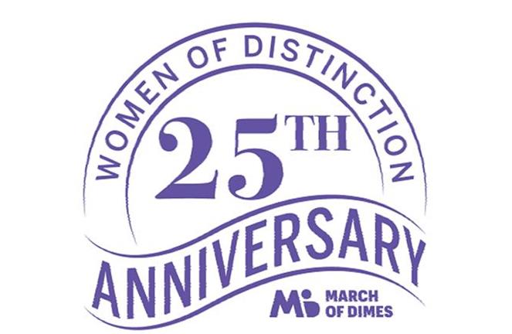

Broward County, Florida – July 22, 2020
A Woman of Distinction: March of Dimes Honoree Monica Figueroa King
The March of Dimes has announced its Honorees for the 2020 Women of Distinction and Monica Figueroa King, CEO of the Broward Healthy Start Coalition is on that list of 10 Honorees.
The March of Dimes is a national organization in existence for more than 75 years that helps moms have healthy full-term pregnancies and healthy babies. The March of Dimes through research and education works to improve birth outcomes so babies have a Healthy Start in life. Since 1995 the local March of Dimes has been honoring women who have made significant contributions to Broward County. March of Dimes honors leaders in their fields and lifelong advocates for promoting equality for women and girls everywhere.
Monica Figueroa King serves as the CEO of the Broward Healthy Start Coalition. The Coalition is a not-for profit that serves as the state designated entity responsible for improving the maternal child health system of care. Monica has spent the last twenty years in the field of Human Services where she has been able to align her work to her passion to support children and families. Prior to Healthy Start, Monica served as the Executive Director of ChildNet, Broward’s site, for three years. Before that, Monica worked for the Children’s Services Council of Broward County for nearly ten years. She has always been committed to public service and improving the quality of life for all of our community.
During this incredibly challenging time for all of us, Monica continues to lead her Healthy Start staff to successfully serve our community’s pregnant women and their families to achieve a successful pregnancy and a healthy start in life.
March of Dimes 2020 Women of Distinction, 25th Anniversary, will be holding a virtual event Friday, November 13, 2020 at 11:45am. To Learn more or purchase tickets visit:
https://www.marchofdimes.org/events/Event.aspx?eventId=21400&

